Question 35:

CODE:

%{

#include <stdio.h>

%}

DIGIT [0-9]+

WORD [a-zA-Z]+

%%

{DIGIT} { printf("Number: %s\n", yytext); }

{WORD} { printf("Word: %s\n", yytext); }

.|\n { /* Ignore other characters */ }

%%

int main() {

yylex();

return 0;

}

int yywrap() {

return 1;

}

OUTPUT:

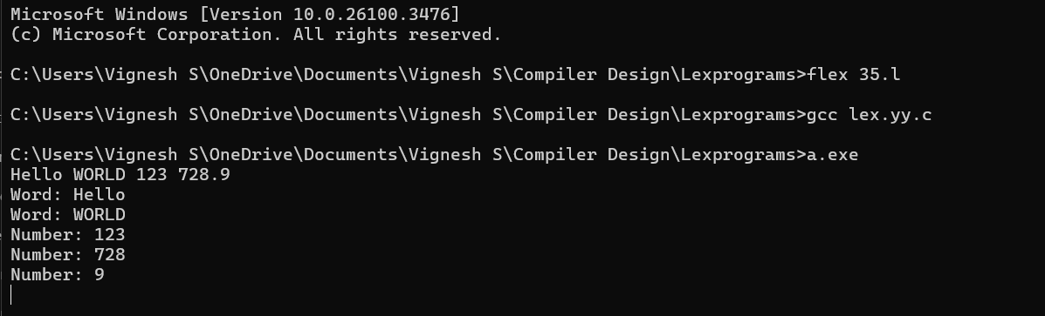

Question 36:

CODE:

%{

#include <stdio.h>

int pos_count = 0, neg_count = 0;

%}

POSITIVE [0-9]+

NEGATIVE -[0-9]+

%%

{POSITIVE} { printf("Positive Number: %s\n", yytext); pos_count++; }

{NEGATIVE} { printf("Negative Number: %s\n", yytext); neg_count++; }

.|\n { /* Ignore other characters */ }

%%

int main() {

yylex();

printf("Total Positive Numbers: %d\n", pos_count);

printf("Total Negative Numbers: %d\n", neg_count);

return 0;

}

int yywrap() {

return 1;

}

OUTPUT:

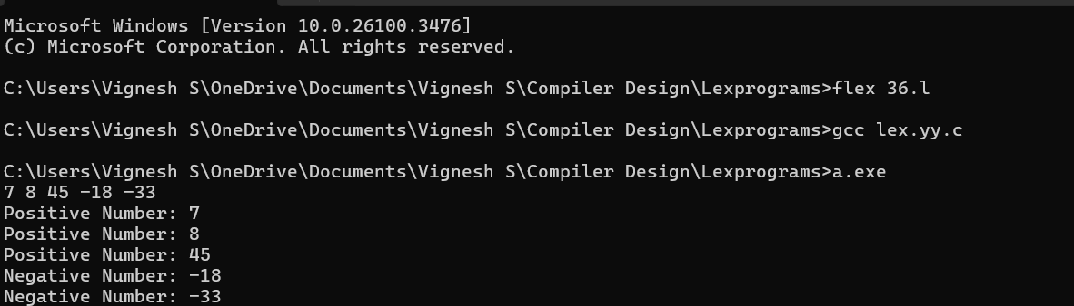

Question 37:

CODE:

%{

#include <stdio.h>

%}

%%

"http://"[a-zA-Z0-9.-]+(\.[a-zA-Z]{2,6})("/"[a-zA-Z0-9?=&._-]*)? {

printf("Valid URL: %s\n", yytext);

}

"https://"[a-zA-Z0-9.-]+(\.[a-zA-Z]{2,6})("/"[a-zA-Z0-9?=&._-]*)? {

printf("Valid URL: %s\n", yytext);

}

.|\n { /* Ignore other characters */ }

%%

int main() {

yylex();

return 0;

}

int yywrap() {

return 1;

}

OUTPUT:

